Week Ending: | DAY: |  |  |  | Subject: Computing
Duration: 60mins |  |  |  |  | Strand: Word Processing
Class: B4 | Class Size: |  |  |  | Sub Strand: Introduction To Word Processing
Content Standard:  B4.3.1.1. Demonstrate understanding of the use of word processing application |  |  | Indicator:  B4.3.1.1.2 Illustrate the use of the clip board, styles, fonts, paragraph and editing |  |  | Lesson:  1 OF 1
Performance Indicator:  - Learners can Illustrate the use of the clip board, styles, fonts, paragraph and editing |  |  |  | Core Competencies:  Creativity and innovation. 2. Communication and collaboration
Teaching/ Learning Resources |  | Images of clipboard, styles, fonts, paragraph
References: Computing Curriculum Pg. 55
DAYS | PHASE 1: STARTER | PHASE 2: MAIN | PHASE 3: REFLECTION
 | Prepare a list of concepts, ideas or objects that relate to the lesson you are about to teach.  Divide the class into four teams. The teacher presents the leaders from each group a concept.  The leader then draw the concepts on the board, whilst his/her term guess what the object is.  The team who guess correctly first wins. | Guide learners to use the clipboard, styles, fonts, paragraph and editing feature under the Home tab and let learners explore on a simple word document.  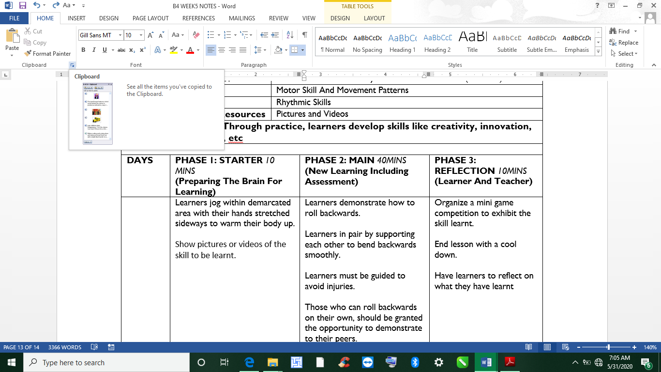 | Ask learners questions to review their understanding of the lesson.  Give learners task to do whiles you go round to guide those who need help.

